https://www.facebook.com/smart.ssr/
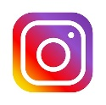
https://www.instagram.com/smartmolodizhniicentr
https://t.me/smartsrr
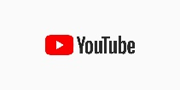
https://www.youtube.com/channel/UCI105WpfNHvD06Csue5qIGQ

